SIMATS ENGINEERING
ASSIGNMENT

Design, develop, and deploy a cloud-based application for managing the property buying and rental process in a selected city/region.

CSA 1511 - CLOUD COMPUTING AND BIG DATA ANALYTICS:
TEAM MEMBERS:
PREETE.V(192572004)
MADHU BAVANA.B(192524103)
KEERTHANA.P(192521289)

1. Problem Statement
Finding suitable residential and commercial properties for buying or renting is a time-consuming process. Customers often need to visit multiple agents and websites to compare properties, prices, amenities, and locations. Property owners also face difficulties in managing listings, rental agreements, and customer enquiries. A cloud-based SaaS solution is required to provide a centralized platform for property listing, searching, buying, renting, agreement management, and customer communication.
2. Objective
- To develop a cloud-based Property Buying and Rental Management System.
- To provide online property listing and search facilities.
- To support buying, renting, and commercial property management.
- To maintain rental agreements digitally.
- To manage customer enquiries efficiently.
- To demonstrate the Software as a Service (SaaS) cloud model.
- To deploy the application on a cloud platform.
3. Requirements and Environment Used
Hardware Requirements
- Processor: Intel Core i3 or above
- RAM: 4 GB minimum
- Storage: 20 GB free space
- Internet Connection
Software Requirements
- Operating System: Windows 10/11
- Cloud Platform: Zoho Creator (SaaS) / Microsoft Azure
- Database: Zoho Creator Database / Azure SQL Database
- Browser: Chrome, Edge, Firefox
Environment Used
Component | Technology
Frontend | Zoho Creator Forms
Backend | Zoho Creator Workflows
Database | Cloud Database
Cloud Service Model | SaaS
Deployment | Zoho Creator Cloud

4. Design / Proposed Solution
Modules
Property Management
- Add Property
- Update Property
- Delete Property
- View Property
Property Search
- Search by Location
- Search by Price
- Search by Property Type
Buy Property
- Purchase Request
- Property Verification
- Payment Details
Rental Management
- Rental Request
- Tenant Details
- Rent Tracking
Commercial Property
- Office Space
- Shops
- Warehouses
Agreement Management
- Rental Agreement
- Agreement Renewal
- Expiry Notification
Customer Enquiry
- Contact Form
- Complaint Management
- Feedback System
5. Algorithm / Pseudocode
Property Listing
START
Enter Property Details
Validate Inputs
IF Details Valid
Save to Database
Display Success Message
ELSE
Display Error Message
ENDIF
STOP
Property Search
START
Enter Search Criteria
Search Database
IF Property Found
Display Results
ELSE
Display "No Property Found"
ENDIF
STOP
PSEUDO CODE
BEGIN
DISPLAY "Property Management System"
LOGIN USER
IF username and password are valid THEN
DISPLAY Dashboard
ELSE
DISPLAY "Invalid Login"
STOP
END IF
WHILE user is logged in
DISPLAY:
1. Property Listing
2. Search Property
3. Buy Property
4. Rent Property
5. Commercial Property
6. Rental Agreement
7. Customer Enquiry
8. Logout
READ choice
IF choice = 1 THEN
INPUT Property ID
INPUT Property Type
INPUT Transaction Type
INPUT City
INPUT Locality
INPUT Area
INPUT Price / Rental
INPUT Property Value
INPUT Amenities
INPUT Property Status
SAVE property details
DISPLAY "Property Added Successfully"
ELSE IF choice = 2 THEN
INPUT Property Type
INPUT Transaction Type
INPUT Location
INPUT Area
INPUT Price Range
SEARCH available properties
IF matching properties exist THEN
DISPLAY property details
ELSE
DISPLAY "No Property Found"
END IF
ELSE IF choice = 3 THEN
SELECT property
DISPLAY property details
IF property status = "Available" THEN
SUBMIT purchase request
UPDATE property status = "Booked"
DISPLAY "Purchase Request Submitted"
ELSE
DISPLAY "Property Not Available"
END IF
ELSE IF choice = 4 THEN
SELECT rental property
DISPLAY rent and deposit details
IF property status = "Available" THEN
SUBMIT rental request
CREATE rental agreement
UPDATE property status = "Rented"
DISPLAY "Rental Successfully Confirmed"
ELSE
DISPLAY "Property Not Available"
END IF
ELSE IF choice = 5 THEN
DISPLAY commercial properties
INPUT location, area and rental range
SEARCH matching commercial properties
DISPLAY results

ELSE IF choice = 6 THEN
INPUT Owner Details
INPUT Tenant Details
INPUT Property Details
INPUT Start Date
INPUT End Date
INPUT Monthly Rent
INPUT Security Deposit
INPUT Notice Period
STORE agreement details
DISPLAY "Rental Agreement Created"
ELSE IF choice = 7 THEN
INPUT Customer Name
INPUT Property ID
INPUT Enquiry Message
SAVE enquiry
DISPLAY "Enquiry Submitted Successfully"
ELSE IF choice = 8 THEN
LOGOUT USER
DISPLAY "Thank You"
BREAK
ELSE
DISPLAY "Invalid Choice"
END IF
END WHILE
END

6. Implementation / Source Code
Property Form Fields
Field Name | Data Type
Property_ID | Auto Number
Property_Type | Dropdown
Transaction_Type | Dropdown
Location | Text
Area | Number
Locality | Text
Price | Currency
Rent | Currency
Amenities | Multi-line
Owner_Name | Text
Contact_No | Number
Agreement Form
Field Name | Data Type
Agreement_ID | Auto Number
Tenant_Name | Text
Property_ID | Lookup
Start_Date | Date
End_Date | Date
Monthly_Rent | Currency
Status | Dropdown
Sample Validation Script
if(input.Price <= 0)
{
alert("Enter Valid Property Price");
}

7. Test Cases and Expected/Actual Results
Test Case | Input | Expected Result | Actual Result | Status
TC01 | Add Property | Property Added | Property Added | Pass
TC02 | Search Property | Property List Displayed | Property List Displayed | Pass
TC03 | Buy Property | Purchase Request Generated | Generated | Pass
TC04 | Rent Property | Rental Request Created | Created | Pass
TC05 | Create Agreement | Agreement Stored | Stored | Pass
TC06 | Submit Enquiry | Enquiry Saved | Saved | Pass

8. Execution Screenshots / Output
Screenshot 1
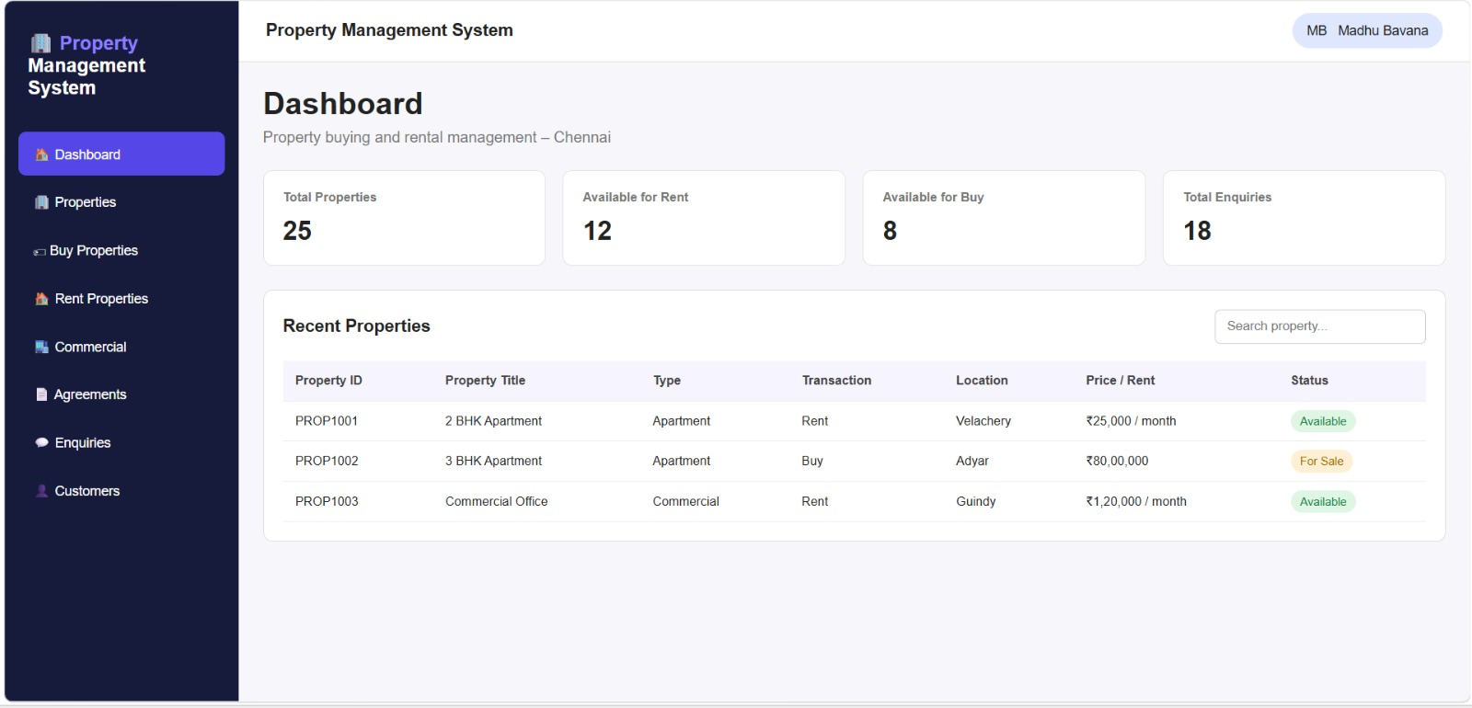

Screenshot 2
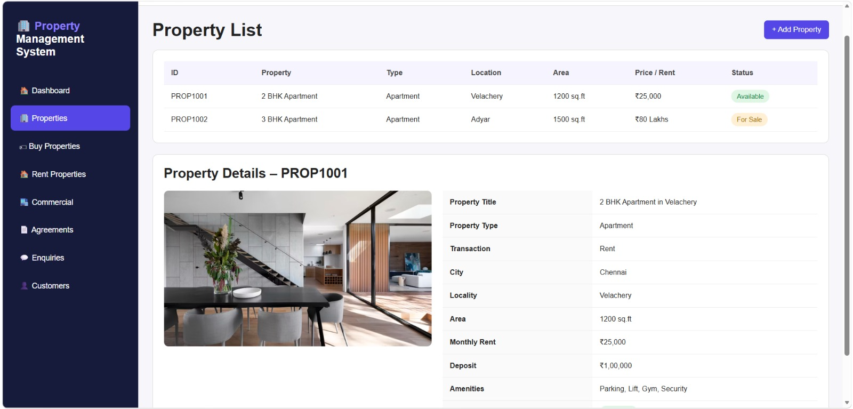
Screenshot 3
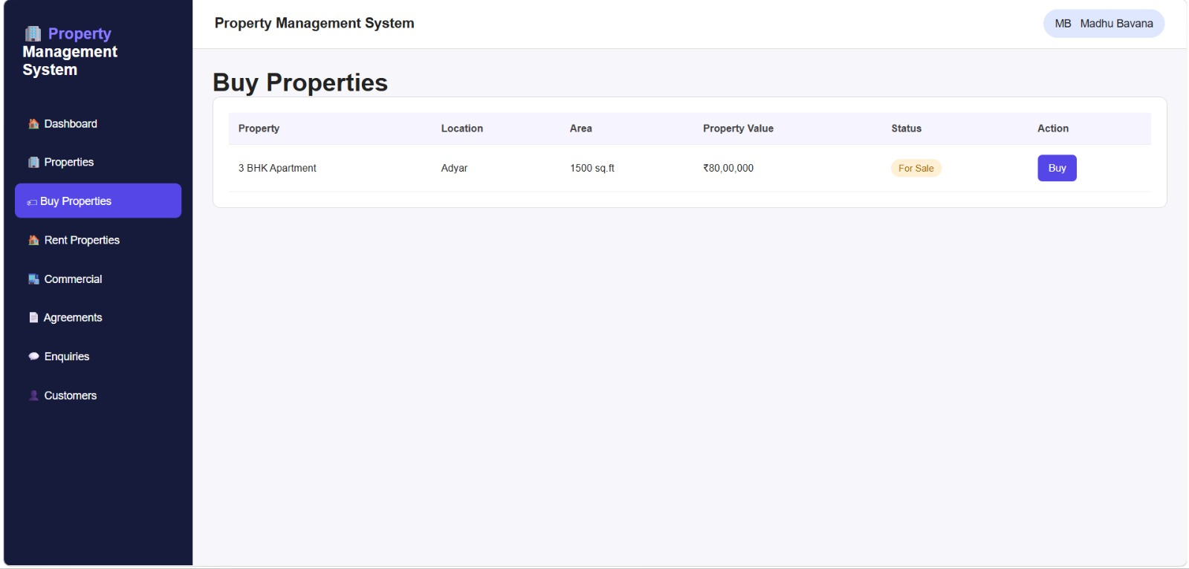

Screenshot 4
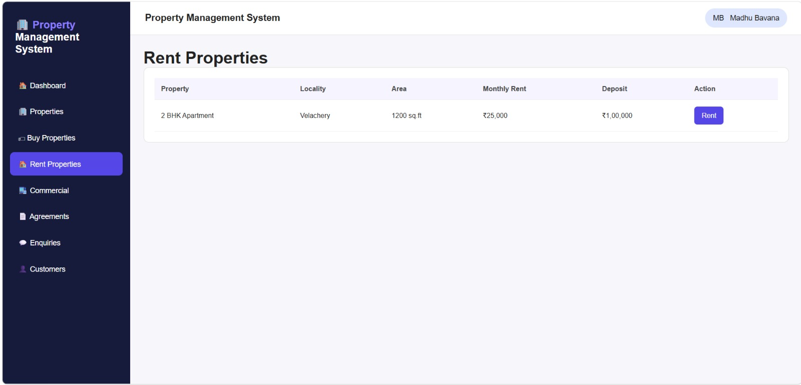
Screenshot 5
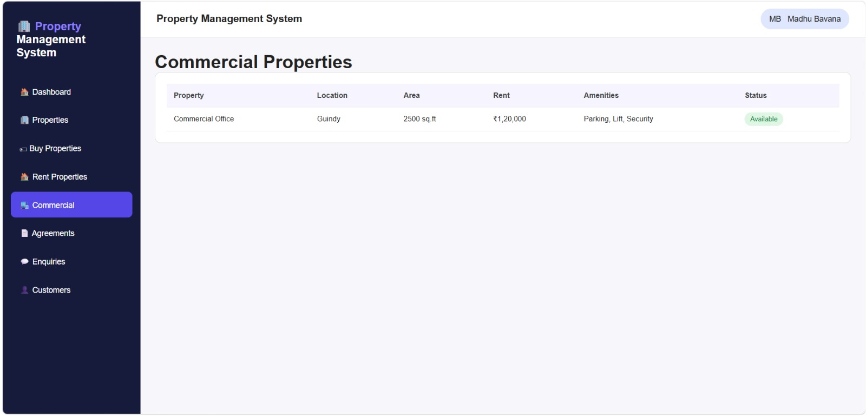

Screenshot 6
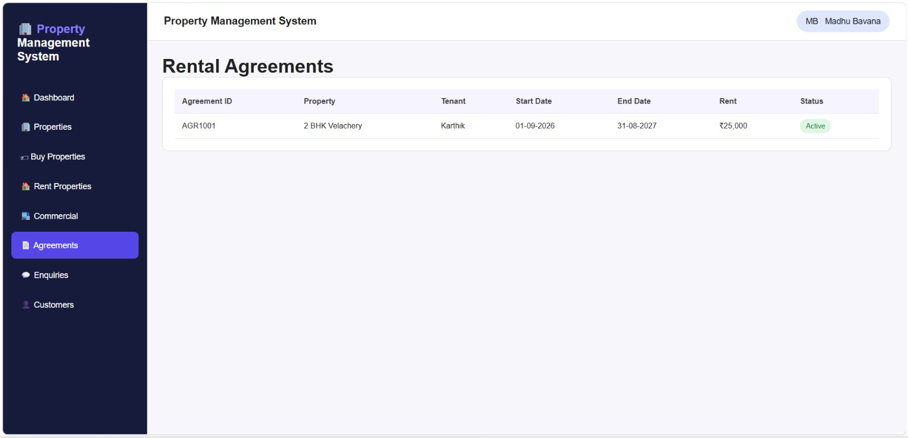
Screenshot 7
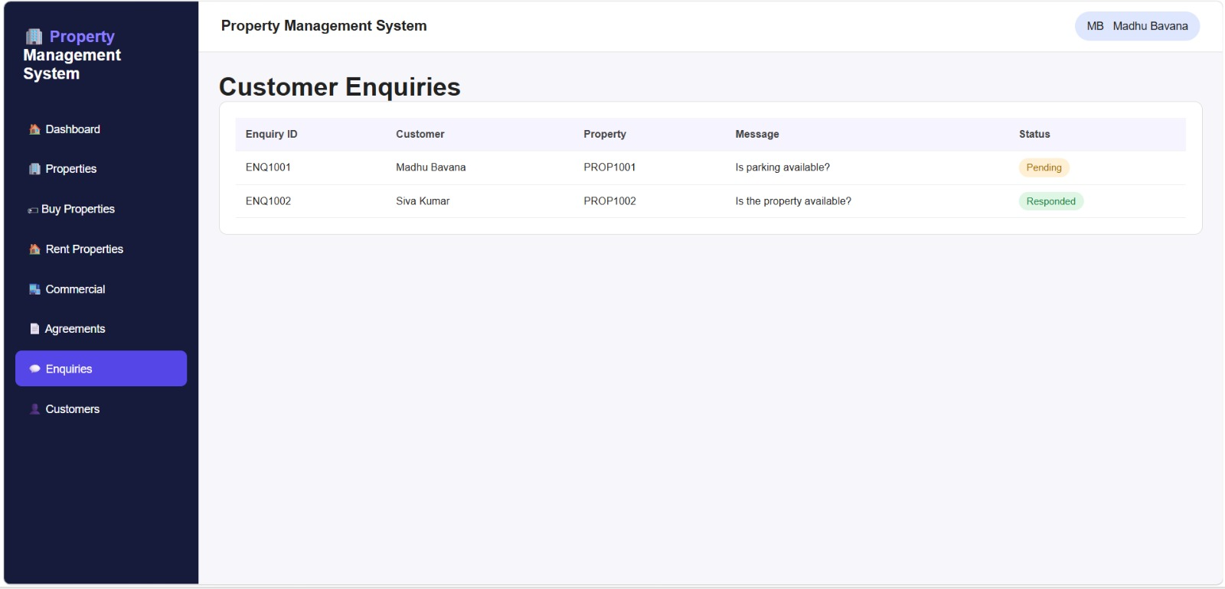

Screenshot 8
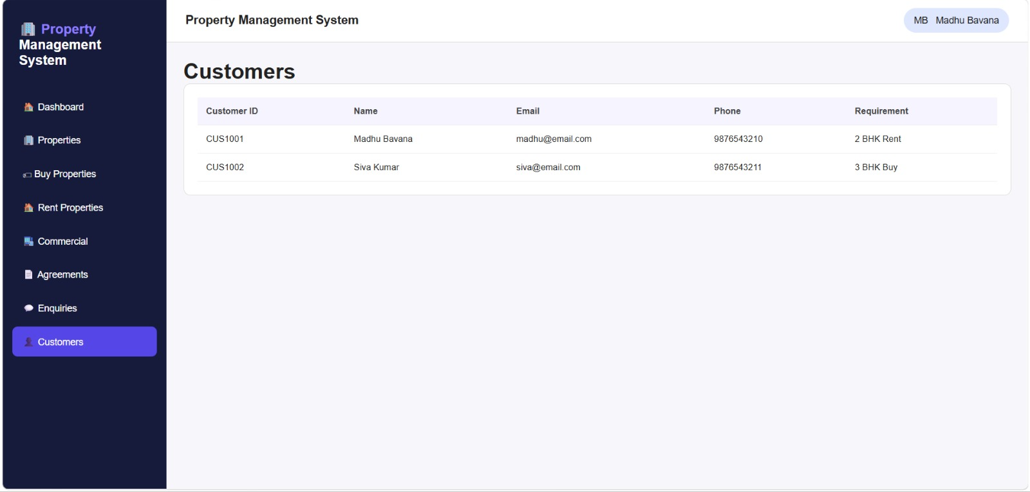

9. Analysis and Discussion
- The SaaS application successfully manages property buying and rental operations.
- Cloud deployment provides accessibility from anywhere.
- Property information is stored securely in cloud databases.
- Search functionality reduces property discovery time.
- Agreement management improves documentation efficiency.
- Customer enquiry management enhances user satisfaction.
- Cloud services provide scalability and availability.
Advantages
- Easy property search
- Centralized management
- Secure cloud storage
- Reduced paperwork
- Real-time updates
- Accessible from any device

10. Conclusion
The Cloud-Based Property Buying and Rental Management System was successfully designed, developed, and deployed using the Software as a Service (SaaS) model. The system provides a centralized platform for managing residential and commercial property transactions, including property listing, searching, buying, renting, rental agreement management, and customer enquiry handling.
By leveraging cloud computing technology, the application enables users to access property information anytime and from anywhere through an internet connection. The cloud-based architecture ensures high availability, scalability, reliability, and efficient data management. Property owners can easily publish and manage property details, while customers can quickly search and compare properties based on location, price, area, and amenities.
The implementation of digital rental agreements and cloud storage significantly reduces paperwork, minimizes manual errors, and improves record maintenance. The customer enquiry module enhances communication between buyers, tenants, and property owners, resulting in improved customer satisfaction and faster decision-making.
Security mechanisms such as user authentication, role-based access control, and cloud data storage help protect sensitive property and customer information. The SaaS deployment model reduces infrastructure costs, simplifies maintenance, and allows future expansion without major hardware investments.
Overall, the developed system successfully demonstrates the practical application of cloud computing concepts in the real estate domain. It provides an efficient, user-friendly, secure, and scalable solution for property management while showcasing the benefits of SaaS-based application deployment. The project achieves all the stated objectives and serves as a strong foundation for future enhancements such as online payment integration, AI-based property recommendations, mobile application support, and advanced analytics for property market trends.

11. Individual Contribution of Group Members
Member 1 :
Contribution 1: Cloud-Based Property Management
Developed a cloud-based Property Management System using HTML, CSS, JavaScript, and cloud technologies to provide a centralized platform for managing residential and commercial properties. The system allows property owners and administrators to add, update, and manage property details such as property type, transaction type, city, locality, area, property value, rental price, amenities, and availability status. Customers can access the application through a web browser and search for suitable properties based on their requirements. The application follows the Software as a Service (SaaS) model, where the system and its data are hosted on the cloud and can be accessed without installing the application locally. This contribution helps simplify property management by maintaining property information in a structured manner and providing a single platform for property listing, buying, renting, and commercial property management.

Member 2:
Automated Property Search and Transaction Management
Implemented an automated property search and transaction management module that makes it easier for customers to find and select suitable properties according to their requirements. The system provides search and filtering options based on important parameters such as property type, transaction type, city, locality, area, price range, rental range, property value, and available amenities. Customers can quickly identify properties available for buying or renting and view complete property details before making a decision. The system also manages purchase and rental requests, allowing administrators or property owners to verify and process customer requests. Once a transaction is confirmed, the property status can be updated automatically as Available, Booked, Sold, or Rented. This contribution reduces manual searching and record maintenance, improves the efficiency of property transactions, and provides customers with a simple and organized way to find properties that match their budget and preferences.
Member 3:
Contribution 3: Digital Rental Agreement and Customer Enquiry Management
Implemented a digital rental agreement and customer enquiry management module to simplify communication and documentation between property owners, tenants, and administrators. The system maintains important rental agreement information such as agreement ID, property ID, owner name, tenant name, agreement start date, end date, monthly rent, security deposit, notice period, and agreement status. This reduces the need for maintaining physical documents and provides organized access to agreement records. The module also allows customers to submit property-related enquiries regarding availability, rent, amenities, location, and other requirements. Administrators or property owners can view these enquiries, provide responses, and update their status as Pending, Responded, or Closed. By combining digital agreement management with enquiry tracking, the system improves communication, reduces manual paperwork, maintains accurate records, and provides a more efficient and transparent cloud-based property rental management process

12. References
- Zoho Creator Official Website
- Microsoft Azure Documentation
- Cloud Computing Concepts by NPTEL
- Rajkumar Buyya, Cloud Computing: Principles and Paradigms.
- Thomas Erl, Cloud Computing Design Patterns.

Project Title: – Cloud-Based SaaS Application for Property Buying & Rental Management (Chennai Region)

Member Name | Individual Contribution
Preete V | Designed the overall cloud architecture and selected appropriate AWS services. Configured the application deployment environment, managed cloud storage and database integration, implemented user authentication and role-based access control, and coordinated the deployment process.
Madhu Bavana B | Designed the database schema and property management modules. Developed property listing, property search, filtering, and customer enquiry functionalities. Implemented data validation, testing of database operations, and integration between application modules and cloud database services.
Keerthana P | Developed the user interface and dashboard components. Created property registration forms, search pages, rental agreement forms, and report generation modules. Conducted application testing, prepared screenshots and documentation, and assisted in deployment verification.

Individual Reflection
Keerthana P
I developed the user interface components and report modules for the application. I designed forms for property registration, rental agreements, and customer enquiries to provide a user-friendly experience. One challenge was ensuring proper communication between frontend forms and backend services. I solved this through extensive testing and validation of form submissions. My contribution helped create an intuitive interface and improved overall usability of the system.

Declaration
We hereby declare that the above information accurately represents the individual contributions made by each team member towards the design, development, testing, deployment, and documentation of the UrbanNest – Cloud-Based SaaS Application for Property Buying & Rental Management project.
Signatures
Keerthana P

